**Waveform Analysis Using the Ambiguity Function**

This example illustrates how to use the ambiguity function to analyze waveforms. It compares the range and Doppler capability of several basic waveforms, e.g., the rectangular waveform and the linear and stepped FM waveform.

In a radar system, the choice of a radar waveform plays an important role in enabling the system to separate two closely located targets, in either range or speed. Therefore, it is often necessary to examine a waveform and understand its resolution and ambiguity in both range and speed domains. In radar, the range is measured using the delay and the speed is measured using the Doppler shift. Thus, the range and the speed are used interchangeably with the delay and the Doppler.

**Introduction**

To improve the signal to noise ratio (SNR), modern radar systems often employ the matched filter in the receiver chain. The ambiguity function of a waveform represents exactly the output of the matched filter when the specified waveform is used as the filter input. This exact representation makes the ambiguity function a popular tool for designing and analyzing waveforms. This approach provides the insight of the resolution capability in both delay and Doppler domains for a given waveform. Based on this analysis, one can then determine whether a waveform is suitable for a particular application.

The following sections use the ambiguity function to explore the range-Doppler relationship for several popular waveforms. To establish a comparison baseline, assume that the design specification of the radar system requires a maximum unambiguous range of 15 km and a range resolution of 1.5 km. For the sake of simplicity, also use 3e8 m/s as the speed of light.

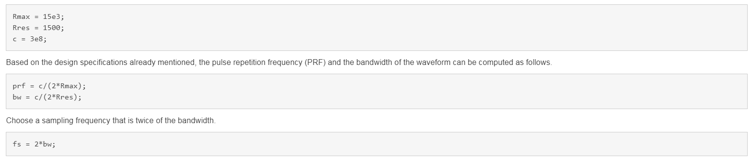

### Rectangular Pulse Waveform

The simplest waveform for a radar system is probably a rectangular waveform, sometimes also referred to as single frequency waveform. For the rectangular waveform, the pulse width is the reciprocal of the bandwidth.

A rectangular waveform can be created as follows.

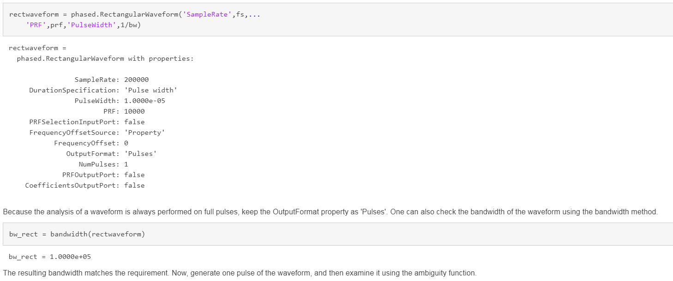

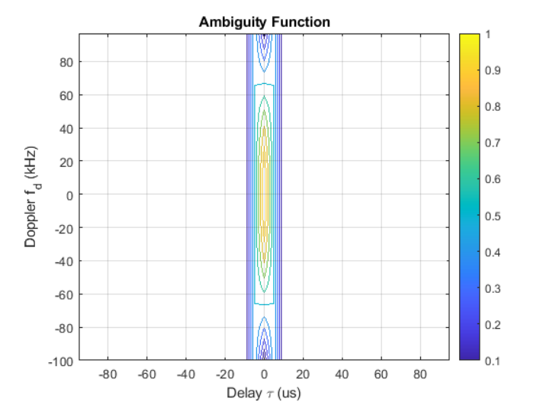

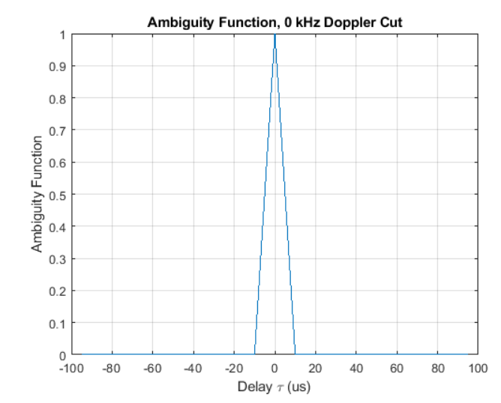

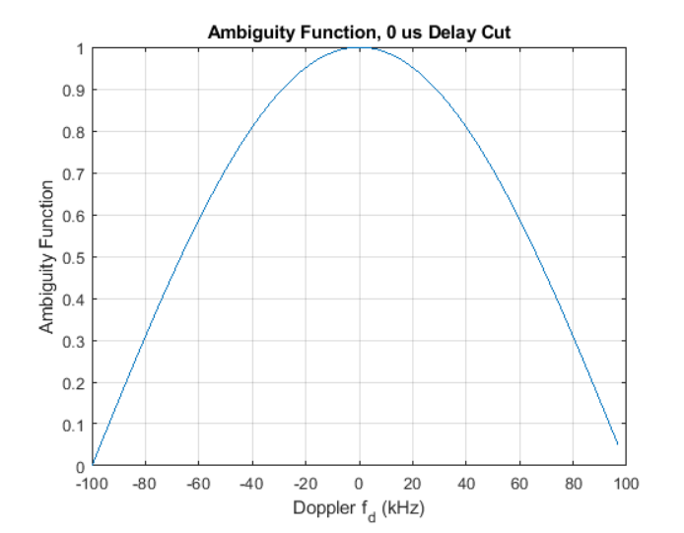

Notice that the returned zero delay response is fairly broad. The first null does not appear till at the edge, which corresponds to a Doppler shift of 100 kHz. Thus, if the two targets are at the same range, they need to have a difference of 100 kHz in the Doppler domain to be separated. Assuming the radar is working at 1 GHz, according to the computation below, such a separation corresponds to a speed difference of 30 km/s. Because this number is so large, essentially one cannot separate two targets in the Doppler domain using this system.

fc = 1e9;

deltav_rect = dop2speed(100e3,c/fc)

deltav_rect = 30000

At this point it may be worth to mention another issue with the rectangular waveform. For a rectangular waveform, the range resolution is determined by the pulse width. Thus, to achieve good range resolution, the system needs to adopt very small pulse width. At the same time, the system also needs to be able to send out enough energy to the space so that the returned echo can be reliably detected. Hence, a narrow pulse width requires very high peak power at the transmitter. In practice, producing such power can be very costly.

**Linear FM Pulse Waveform**

One can see from the previous section that the Doppler resolution for a single rectangular pulse is fairly poor. In fact, the Doppler resolution for a single rectangular pulse is given by the reciprocal of its pulse width. Recall that the delay resolution of a rectangular waveform is given by its pulse width. Apparently, there exists a conflict of interest between range and Doppler resolutions of a rectangular waveform.

The root issue here is that both the delay and the Doppler resolution depend on the pulse width in opposite ways. Therefore, one way to solve this issue is to come up a waveform that decouples this dependency. One can then improve the resolution in both domains simultaneously.

Linear FM waveform is just such a waveform. The range resolution of a linear FM waveform is no longer depending on the pulse width. Instead, the range resolution is determined by the sweep bandwidth.

In linear FM waveform, because the range resolution is now determined by the sweep bandwidth, the system can afford a longer pulse width. Hence, the power requirement is alleviated. Meanwhile, because of the longer pulse width, the Doppler resolution improves. This improvement occurs even though the Doppler resolution of a linear FM waveform is still given by the reciprocal of the pulse width.

Now, explore the linear FM waveform in detail. The linear FM waveform that provides the desired range resolution can be constructed as follows.

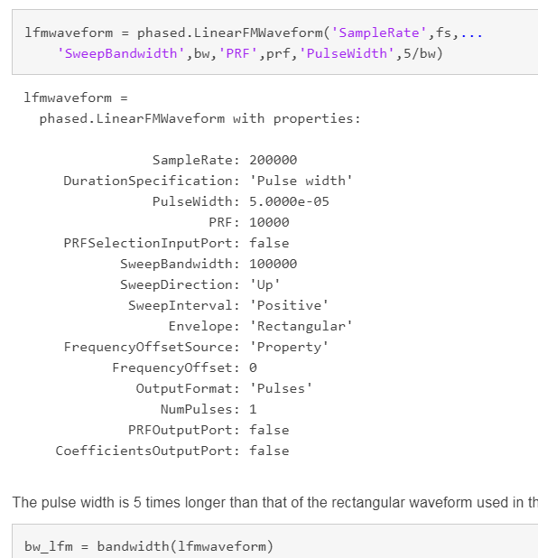

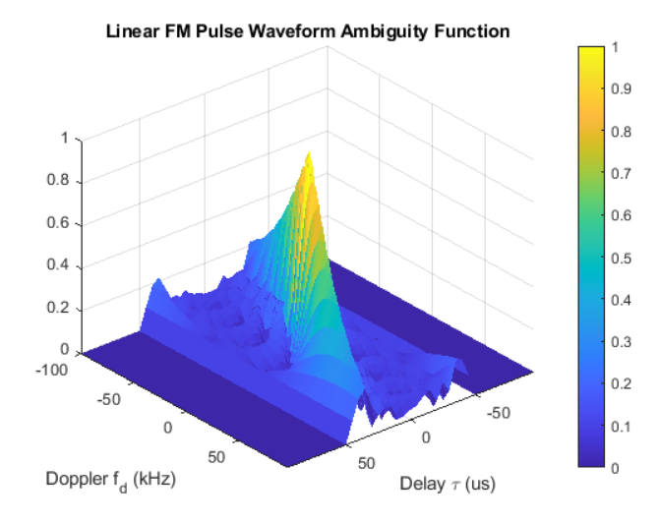

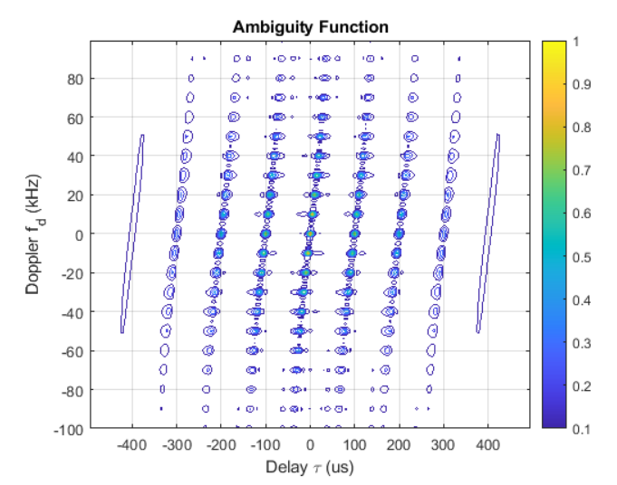

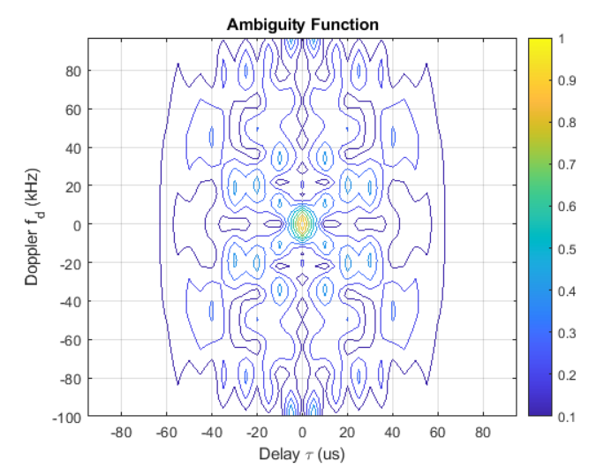

### Summary

This example compared several popular waveforms including the rectangular waveform, the linear FM waveform, the stepped FM waveform and the Barker-coded waveform. It also showed how to use the ambiguity function to analyze these waveforms and determine their resolution capabilities.